SERVICE COORDINATOR ASSIGNING PROCESS

The status of the issue is material despatched,

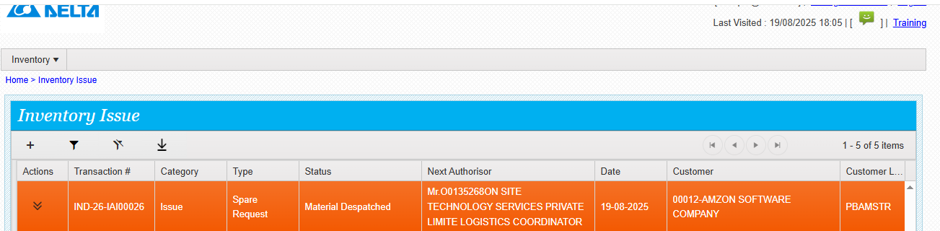

Service coordinator do the following steps

URL- <https://mcis.deltaiserve.net/>

1)Type the URL , enter the login credential and do the login

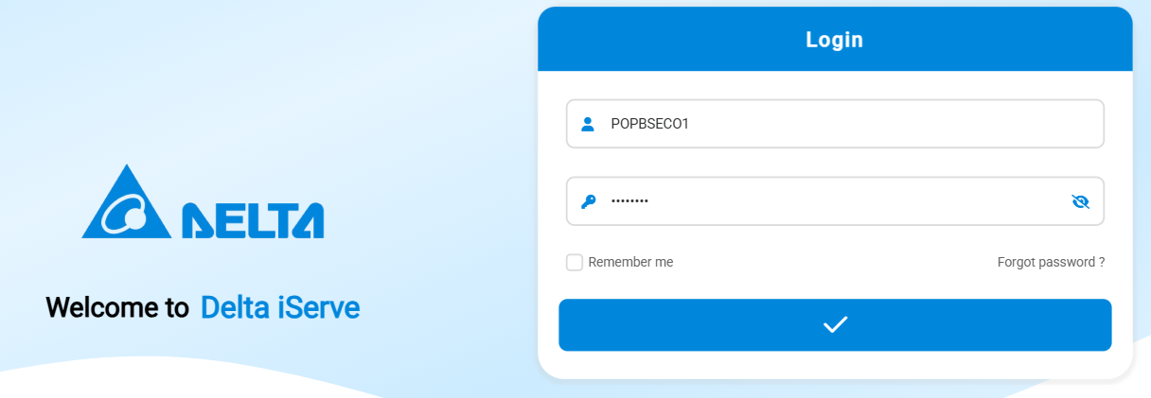

Go to service job management and see the assigned service call

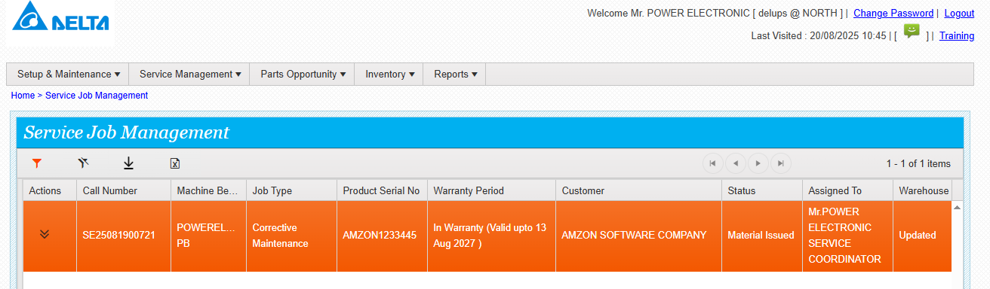Go to action and click and see the actions available

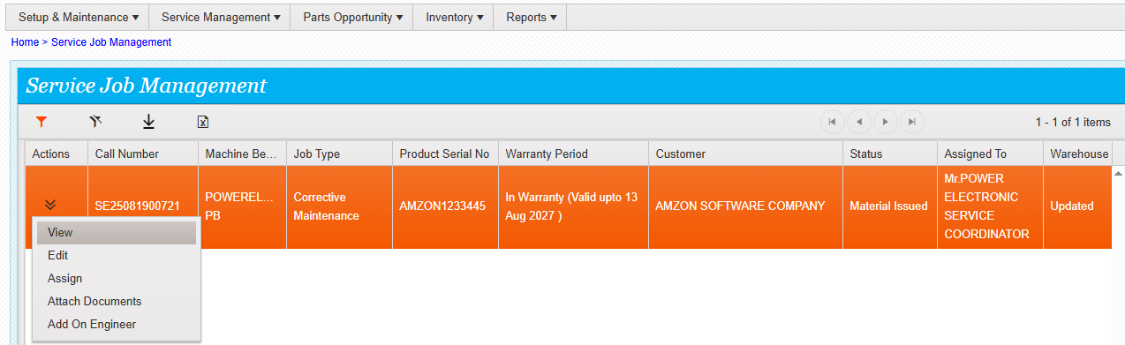

Click assign and see the assignee list

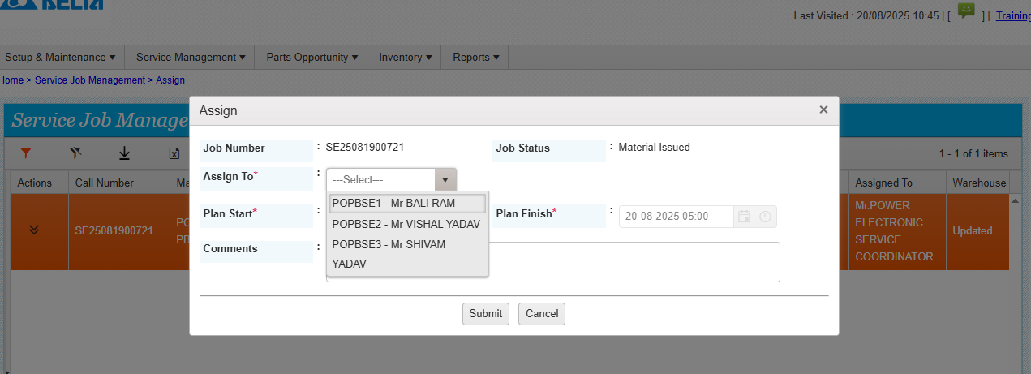

Select the engineer name and submit ,service job assigned successfully.

